Components in this toolbox allow viewing and emailing mainframe files with Windows PC workstation programs and transferring files between mainframe systems and PC Workstations, including network drives, at speeds typically twenty times faster than speeds provided by IND$FILE. These components supplement and address some of the limitations of standard ISPF Client Server.

Interactive functions of this Toolbox require an active connection between a mainframe ISPF session and an ISPF Workstation Agent running on a Windows PC workstation. Since dialogs automatically display the “Initiate Workstation Connection” panel when a workstation connection is needed, it is not necessary to use the WSCON command to initiate a connection. The FILEXFER batch procedure and the batch options of the interactive DOWNLOAD and UPLOAD dialogs run ISPF in batch mode and establish their own workstation connections.

The first group of dialogs described below can be used both as line commands on DSLIST (ISPF 3.4) and as edit macros on the command lines of Edit and View sessions. To use in SDSF, first select a report with the “SE” line command.

DOWNLOAD or DNLD | Download a mainframe file to a menu selectable folder on a PC workstation or network drive interactively or with a generated batch job.
NOTEPAD | Display a mainframe file in Microsoft Notepad.
WORDPAD | Display a mainframe file in Microsoft WordPad.
WORD | Display a mainframe file in Microsoft Word.
EMAIL | Attach a mainframe file to a new Microsoft Outlook email.
OPENWITH | Download a mainframe file, open an Explorer window showing the downloaded file, and prompt the operator to open the file with a program of his choice.
UPLOAD or UPLD | Command that uploads file from a menu selectable folder on a PC workstation or network drive to a mainframe system interactively or with a generated batch job.
MFEDIT | Command that edits a file on a PC workstation or network drive with mainframe ISPF Edit. Changes made in mainframe ISPF can be saved to the PC workstation file.
FILEXFER | Batch procedure for transferring sequential or UNIX files or partitioned data set members. Suitable for reusable batch jobs, for transferring multiple files and for combining file transfers with other actions.

Connecting the ISPF session to the Workstation Agent
Dialogs in this toolbox check for an existing connection between the mainframe ISPF session and the ISPF Workstation Agent. If an Interactive activity is selected and a connection does not already exist, the operator is prompted to initiate a workstation connection.
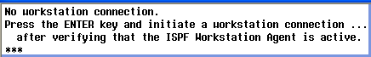
When the Initiate Workstation Connection panel is displayed, pressing the Enter key establishes a connection.
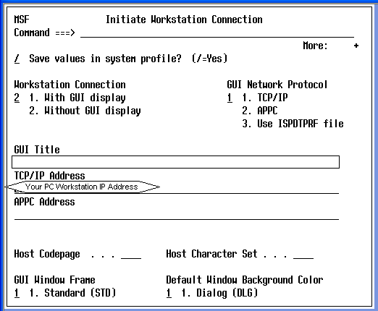

A connection between an interactive ISPF session and a Workstation Agent is not required for a batch activity since a batch job establishes its own connection. The Workstation Agent, however, must be running, should be configured to automatically accept incoming connection requests and must remain active until all batch jobs using it or waiting to use it have completed. Do not shut down or log off from a PC workstation while there are batch jobs using or waiting to use the Workstation Agent. Multiple mainframe batch file transfer jobs can run concurrently with each establishing its own connection with the Workstation Agent.
DOWNLOAD/DNLD – Download a mainframe file
The DOWNLOAD dialog transfers a mainframe sequential file or a PDS member to a folder on a PC workstation or network server. DNLD acts as a synonym for DOWNLOAD. DOWNLOAD allows transferring files to directory paths and file names that are substantially longer than those allowed by the ISPF Client Server file transfer panel (ISPF 3.7.2). Up to 148 characters are allowed for paths and up to 56 characters are allowed for workstation file names.
Type DOWNLOAD or DNLD by a file name on the DSLIST (ISPF 3.4) panel and press Enter …
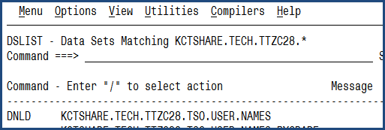

Select the Working Directory to which the file will be transferred. (Up to four Working Directory paths can be entered and stored.) Optionally modify the Workstation file name using only characters valid for Microsoft Windows file names. Modify options at the bottom of the panel as needed. Press the Enter key.
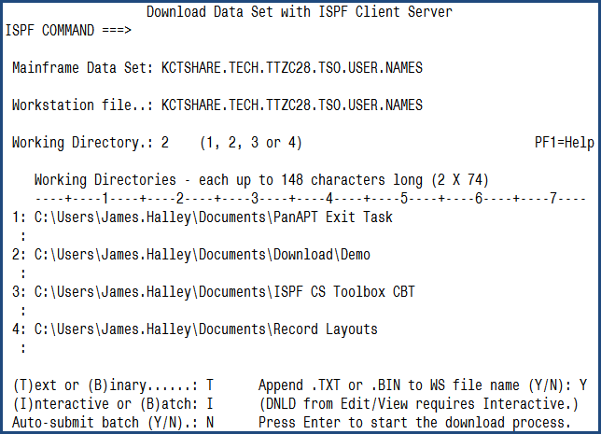

Using characters in a Workstation file name that are not allowed by Microsoft Windows trigger the display of “Invalid file name”. Pressing PF1 displays additional information:
The following default values are assigned the first time DOWNLOAD is invoked.
- (T)ext or (B)inary is set to “T” for Text
- (I)nteractive or (B)atch is set to “I” for Interactive
- Auto-submit batch is set to “N”
- Append .TXT or .BIN to WS file name (Y/N) is set to “Y”

All panel field values, except Mainframe Data Set and Workstation file name, are retained from session to session.
If Interactive mode was selected, a message is displayed after the download has completed:
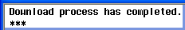
The mainframe file is now on the PC workstation or network drive:
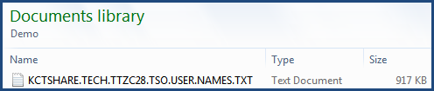

Downloading a member of a Partitioned Data Set
Select the PDS with the “M” line command from DSLIST (ISPF 3.4) and then use DOWNLOAD or DNLD as a line command.
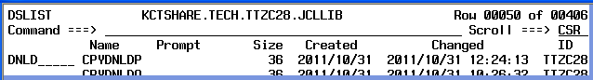
DOWNLOAD/DNLD can also be used as a primary command on an ISPF command line either by entering TSO DOWNLOAD or TSO DNLD and the mainframe data set name or by entering only TSO DOWNLOAD or TSO DNLD and then entering the file name when prompted. The file name must in these cases be enclosed by apostrophes.

Downloading the contents of an Edit and View Sessions
DOWNLOAD/DNLD can be used as an edit macro on the command lines of Edit and View sessions to transfer a mainframe file, PDS member, report from SDSF or a module from CA Librarian ELIPS to a folder on a PC workstation or network drive. To transfer a report from SDSF, first select the report with the “SE” (select edit) line command.
Type DOWNLOAD or DNLD on the Command line while in an Edit or View session …
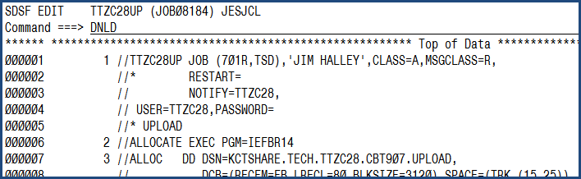
Press Enter after verifying/changing the Workstation file name and Working Directory …
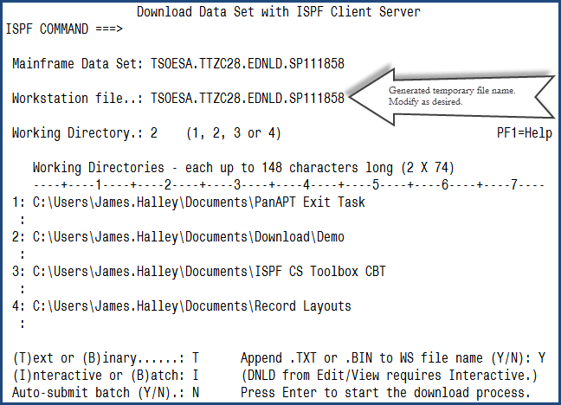
Interactive mode is required when DOWNLOAD or DNLD is used in an Edit or View session.
A message is displayed when the file transfer has completed:
The renamed mainframe file or report is now on the PC Workstation or network drive:
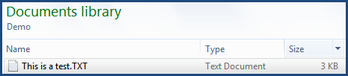
NOTEPAD/WORDPAD/WORD – Display a mainframe file in Microsoft Notepad, WordPad or Word
NOTEPAD, WORDPAD and WORD can be used as line commands on DSLIST (ISPF 3.4) to download and view the contents of a sequential file or a member of a partitioned data set. Changes made in Microsoft Notepad, WordPad and Word are not saved back to the mainframe file.
The following example shows the use of NOTEPAD as a line command on the DSLIST panel.
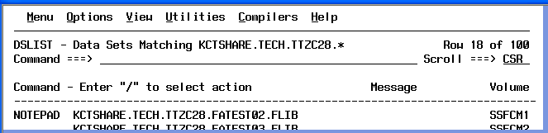
An informational message is displayed.
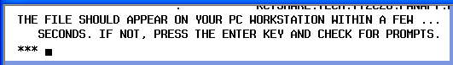
The application displaying the file may open behind other open windows and can be brought to the front by clicking its Windows taskbar icon.
If a file is not downloaded and displayed in a length of time commensurate with its size, pressing the Enter key may show that the file contains non-displayable characters. Enter a slash to continue.
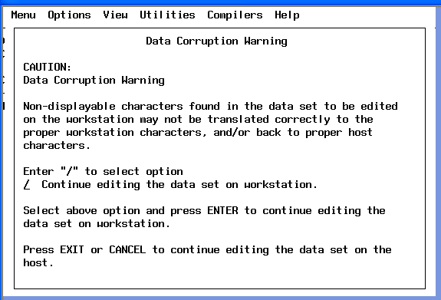
NOTEPAD/WORDPAD/WORD – Display the contents of Edit and View sessions in Microsoft Notepad, WordPad or Word
NOTEPAD, WORDPAD and WORD can also be used as edit macros on command lines of Edit and View sessions to view a mainframe file, PDS member or report with Microsoft Notepad, WordPad or Word. To use in SDSF, select reports with the “SE” (select edit) line command.
Example: When in an Edit or View session, type NOTEPAD on the command line:
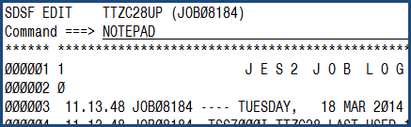
When you see this message …
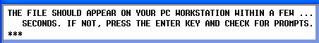
… Microsoft Notepad will automatically open and display the mainframe file or report:
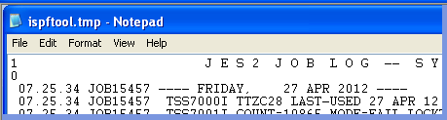

The following actions in Microsoft Word allow 133 character mainframe reports to display without word wrapping:
CTL+A to select all content.
Select the Home tab; set the font to Courier; Set the font size to 8.
Select the Page Layout tab; set Margins to Narrow; set Orientation to Landscape
File … Save as … Word Document (*.docx) or in the format of your choice
EMAIL – Email a file with Microsoft Outlook
EMAIL can be used as a line command on the DSLIST (ISPF 3.4) panel to attach a sequential file or PDS/PDSE member to a new Microsoft Outlook email.
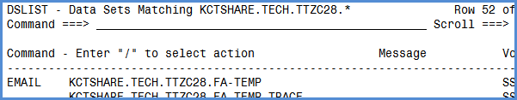
The Email Attachment panel is displayed and requires the one-time entry of a path to a working directory (i.e. folder) on the PC workstation that will receive the file before it is attached to a new email.
Suggestion: Create the working directory as a subfolder of the Workstation Agent installation folder where WSA.EXE resides as shown in the example in the following screen image.
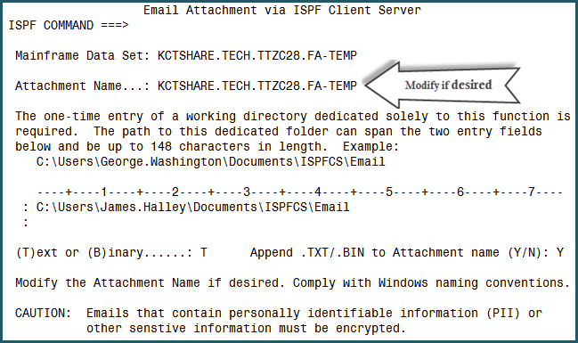
Pressing the Enter key downloads the file to the working directory, displays the following message and attaches the downloaded file to a new email.
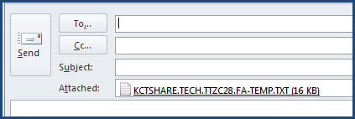
EMAIL – Emailing the contents of an Edit or View session
EMAIL can also be used as an edit macro in Edit and View sessions to attach a mainframe report or file to a new email. To use in SDSF, display the report in an Edit session by selecting it with the “SE” line command. (SE = Select, Edit)
OPENWITH – Download and Open with the program of your choice

OPENWITH can be used as a line command on DSLIST (ISPF 3.4) and as a primary command in an Edit or View session to download a file to the EMAIL dialog’s working directory. OPENWITH then opens a Windows Explorer window and prompts the user to choose the program with which he wishes to open the file. The user can alternatively perform other actions such as renaming the file and sending the renamed file to an Email recipient.

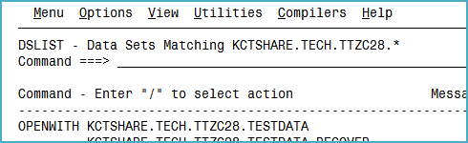

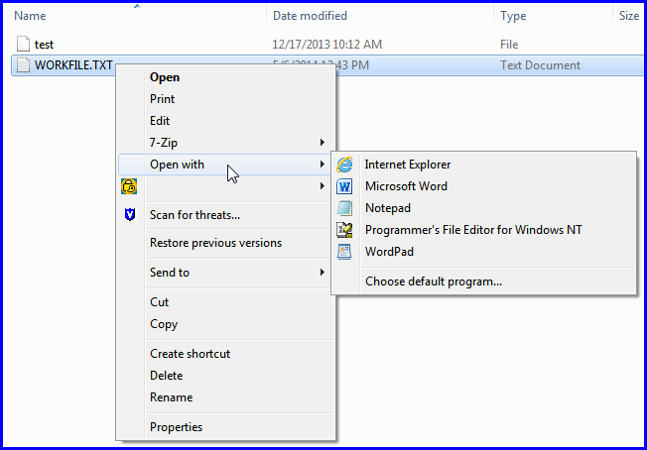
UPLOAD/UPLD – Upload a file to the mainframe
UPLOAD is essentially the reverse of the DOWNLOAD/DNLD command and provides a way to transfer a PC workstation or server file to a mainframe sequential file or PDS member. UPLD acts as a synonym for UPLOAD. UPLOAD can be used to create a new mainframe file or a new member in a new or existing PDS. UPLOAD can be used to replace the contents of an existing sequential file or PDS member.
Most fields on the UPLOAD panel are shared with the DOWNLOAD and MFEDIT panels. If a Working Directory or an option on one panel is changed, the change is reflected on the other panels.
If the target mainframe file does not already exist, the operator is prompted to allocate it with ISPF 3.2.
Example 1 – UPLOAD/UPLD as a primary command
In this example, a PC Workstation file is uploaded from a directory whose path name has been entered in one of the four Working Directory fields of the Upload panel.
Type TSO UPLOAD or TSO UPLD on any ISPF command line. When prompted, enter the name of the target mainframe file enclosed in apostrophes. Then press the Enter key.
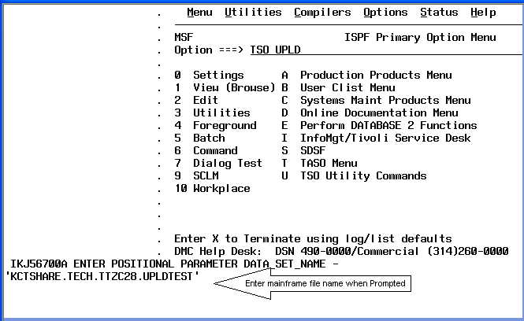
Modify the Workstation file name field to exactly match the name of the file to be uploaded. The entered Workstation file name must be fully coded including the file extension if it has one.
Choose the number (1, 2, 3 or 4) of the Working Directory in which the Workstation file resides.
Enter the Working Directory path in the corresponding field if it has not been entered during a previous activity.
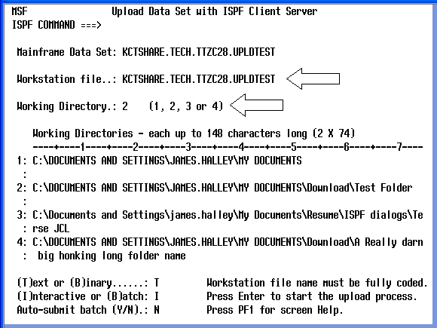

In this example, the file being uploaded is FATEST01.TXT which resides in Working Directory #2:
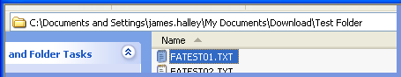
The following image shows the Upload panel after the necessary data entry and modifications have been performed. Pressing the Enter key starts the upload process.
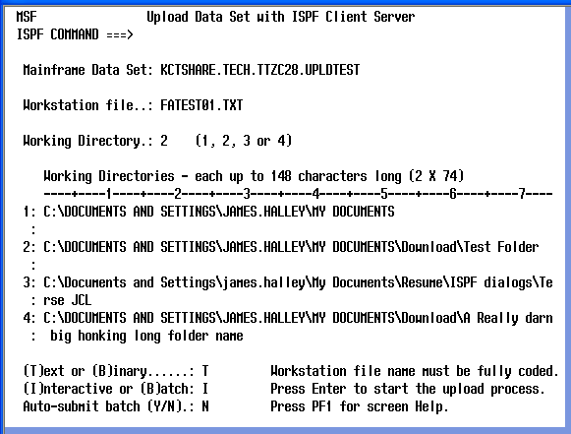

If the target mainframe file does not exist, the operator is prompted to capture the file name so that it can be pasted into the Data Set Utility panel:
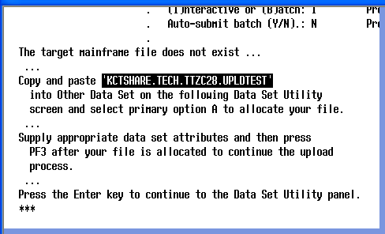
Enter “A” in the option field of the Data Set Utility screen and then paste the file name into the Other Partitioned, Sequential or VSAM Data Set Name field. Press the Enter key:
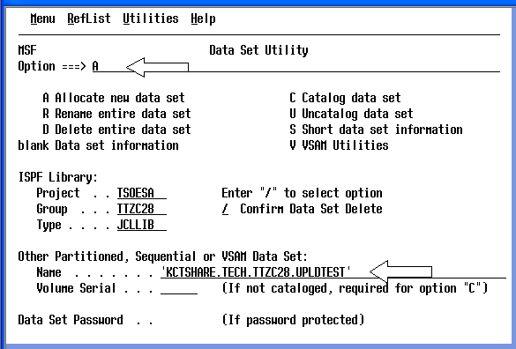
Enter the dataset attributes for the new file on the Allocate New Data Set panel. Press the Enter key to allocate the file.
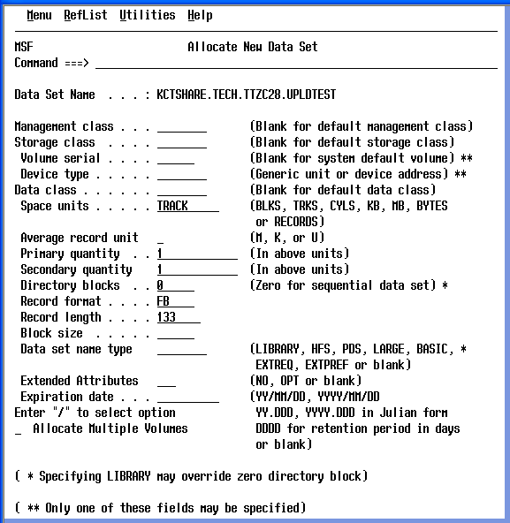
When the Data Set Utility screen is redisplayed with the “Data set allocated” message, press PF3 to start the file upload.
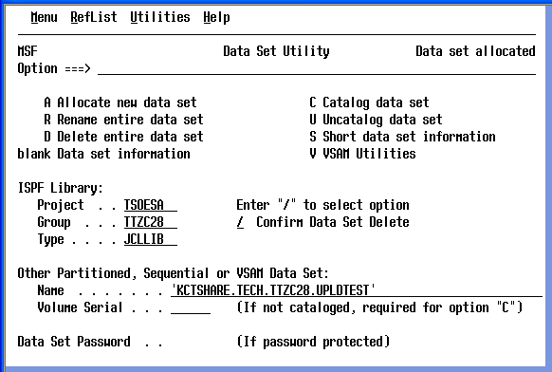
If the file upload is being done interactively, “Upload process has completed” is displayed when the file transfer has finished.
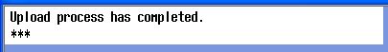
Press Enter or PF3 to return to the Upload Data Set panel:
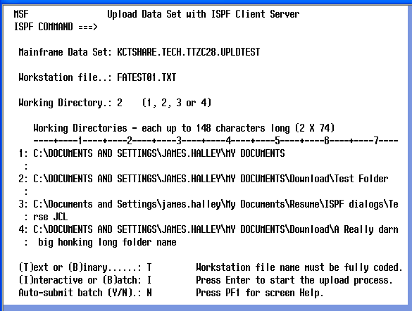
Pressing PF3 again returns you to the panel on which TSO UPLOAD or TSO UPLD was typed.
A convenient method of replacing the contents of an existing file is to type UPLD or UPLOAD by the file name on the DSLIST (ISPF 3.4) panel:
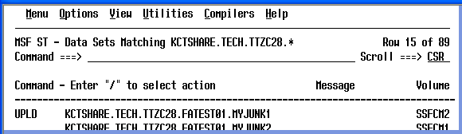
To replace a member of a PDS or PDSE, select the PDS/PDSE from DSLIST with the “M” line command and then type UPLD or UPLOAD by the member name:
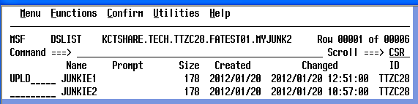
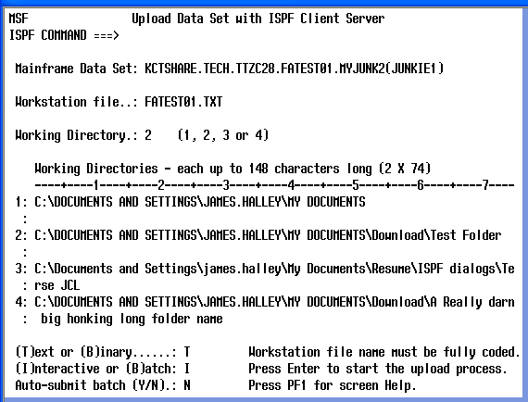
MFEDIT – Edit/modify a PC workstation file with mainframe ISPF
MFEDIT (“Mainframe Edit”) addresses the workstation file name field length limitation of the standard ISPF Edit Entry Panel and the impracticality of changing the Working Directory on the Tool Configuration Integration panel each time a different working directory is required.
The MFEDIT panel allows storing up to four working directories – each up to 148 characters long. The MFEDIT panel shares these four working directory fields with the DOWNLOAD and UPLOAD panels – change a working directory on one panel and it changes on the other panels.
MFEDIT can be used to edit an existing workstation file or to create a new one. As with the standard ISPF Edit Entry Panel, workstation files with records longer than 255 bytes are “wrapped” and converted to 255 byte records if the file is saved. Use MFEDIT with caution to prevent corrupting PC workstation files.
The following example shows editing the PC workstation file.
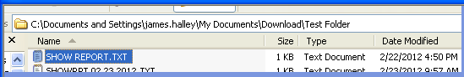
To invoke MFEDIT, type TSO MFEDIT on any ISPF command line. Enter/choose the working directory in which the file is stored and enter the file name, including extension, in the Workstation file field.
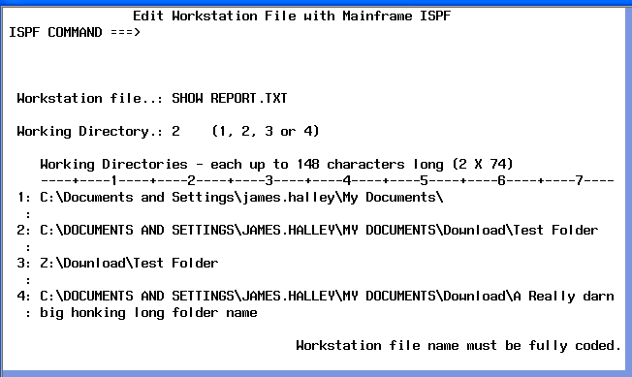
The workstation file – in this case a report – is displayed in a standard ISPF Edit session:
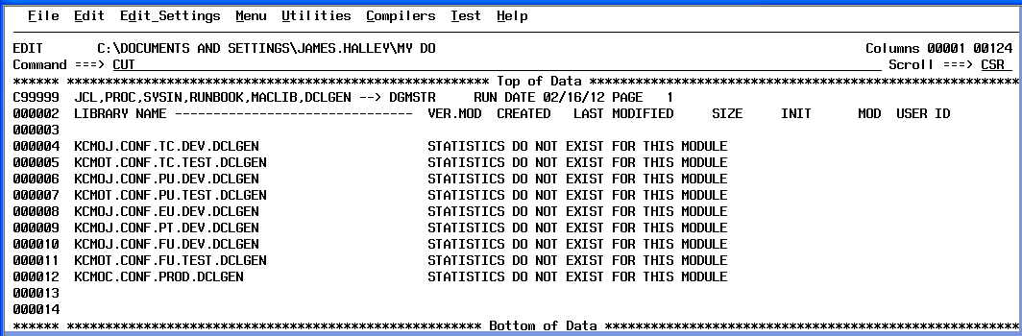
In the above example, the ISPF “CUT” command is used to copy the contents of the workstation file into the ISPF clipboard so that the contents can be pasted into a mainframe file with the ISPF “PASTE” command. ISPF command CREATE can be used to retrieve data from workstation files.
The following image shows adding a comment to the workstation file and then saving the file to the workstation with the SAVE primary command.
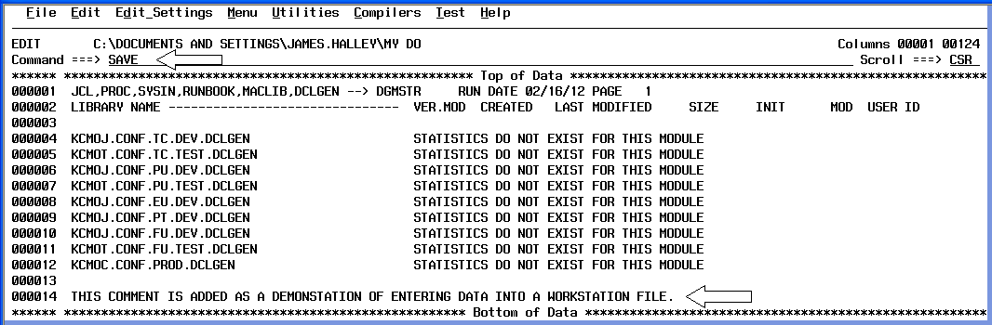
A message is displayed indicating that the workstation file has been saved:
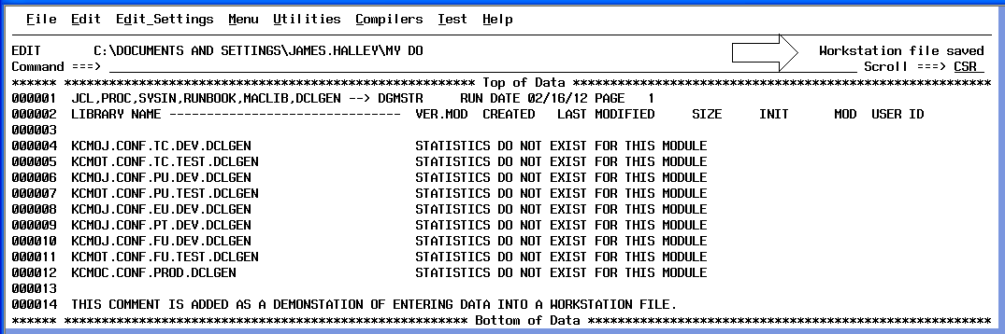
The Date Modified field in Microsoft Windows Explorer shows the data and time that mainframe ISPF saved the workstation file:
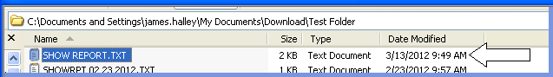

Transferring a file in Batch Mode with DOWNLOAD or UPLOAD
Transferring files in batch mode does not tie up an ISPF session and does not require an active workstation connection. A generated batch job establishes its own connection with the workstation agent. Batch mode is particularly useful for large files. Batch mode is not recommended when invoking DOWNLOAD or UPLOAD from a View or Edit session since the temporary data set created during the process will be automatically deleted if the DOWNLOAD or UPLOAD dialog is exited before the generated batch job begins to run.
When transferring a file in Batch mode with DOWNLOAD or UPLOAD, choose between automatically submitting the JCL or viewing and manually submitting the JCL.
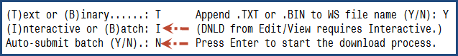
If Batch mode is chosen and “Auto-submit batch” is set to “N”, the generated JCL is displayed for review and manual submission.
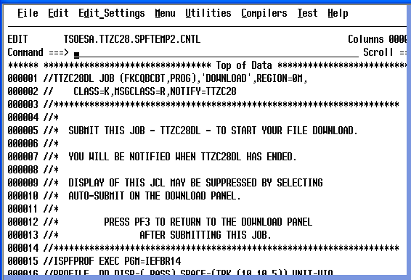
Reasons to display and manually submit generated file transfer job JCL include changing the job name or Class under which the job runs and using a CREATE command to capture the JCL for later use.
A one track temporary PDS control file is created and deleted when DOWNLOAD/DNLD and UPLOAD/UPLD runs in batch mode. If you display the generated JCL but do not submit it, the temporary control file is not deleted. It may be necessary to manually delete “orphan” control files.
Control file names are in the format “prefix.userid.DOWNLOAD.Dyymmdd.Thhmmss” for DOWNLOAD/DNLD and “prefix.userid.UPLOAD.Dyymmdd.Thhmmss” for UPLOAD/UPLD with the last two name nodes being the date and time the control file was created. For environments in which the User ID is the default prefix, the first node of the control file name will be the User ID.
FILEXFER Batch Procedure
The batch FILEXFER procedure is particularly useful when the same files are transferred on a regular basis or when file transfers and other actions are performed in the same batch job. Batch FILEXFER is the only facility described in this document that can transfer z/OS UNIX files. Additional instructions and examples are in the FILEXFER execution JCL member.
The following sample FILEXFER JCL downloads a mainframe sequential file to a PC workstation:

//STEP1 EXEC FILEXFER
//INPUT DD *
IP='000.000.00.00'
MF='ABCDE.CFMU.X1234UMA.DXDXRECS.C12E59'
PC='C:\DOCUMENTS AND SETTINGS\JAMES.HALLEY\MY DOCUMENTS\'
PC='DEMO FOLDER\'
PC='X1234UMA.DXDXRECS.C12E59.TXT'
//* TG='PC' TRANSFER TARGET = PC WORKSTATION (DEFAULT)
//* TG='MF' TRANSFER TARGET = MAINFRAME
//* TY='TEXT' TRANSFER TYPE = TEXT (DEFAULT)
//* TY='BINARY' TRANSFER TYPE = BINARY

Comments (//*) in the above example show the format and values of the optional “TG” (TarGet) and “TY” (TYpe) control cards. If the TG and TY control cards are omitted, the default is to transfer the file from the mainframe to the PC workstation in text mode.

The following control card example downloads a z/OS UNIX file to a PC workstation:
IP='000.000.00.00'
PC='C:\USERS\JAMES.HALLEY\DOCUMENTS\DOWNLOAD\DEMO\ '
PC=' FOLDER WITH SPACES\'
PC='PQYXY_Disb_Transaction_Build.log'
MF='/usr/lzz/pub/web/APPS/'
MF='PQYXY/PROD/PROVIDER/WSDIR'
MF='/PQYXY_Disb_Transaction_Build.log'

Control card “data” after the equal sign, including embedded spaces, must be enclosed within apostrophes. All 80 positions of control cards can be utilized.

Up to three PC= control cards are allowed. Order matters. When multiple PC= control cards are provided, the directory and file name information, including trailing spaces, enclosed within apostrophes are concatenated to construct the path. As shown in the above example and unless the path is extremely lengthy, it can be advantageous to finish coding a subfolder name on one PC= control card and to start the next subfolder name on the next PC= control card. The example also shows placing the PC workstation file name on a separate PC= control card. The use of drive mapping and paths coded in the SFN (Short File Name) format are acceptable.

Up to fourteen MF= control cards are accepted to allow the maximum UNIX path of 1,023 positions to be coded. Only one MF= control card is allowed when the mainframe file is a sequential file or a partitioned dataset member.
How to get started
Install and configure the ISPF Workstation Agent and configure mainframe ISPF per the instructions provided in the ISPF User’s Guide or by your mainframe support staff. Configuration requires the entry of the IP address of the PC workstation on the WSCON panel of ISPF and the entry of the IP address of the mainframe system(s) in the System Register of the ISPF Workstation Agent.
TSO Region Size considerations
TSO region size must be considered for use of the edit macro components of this toolbox and especially on SDSF where the SE line command is used to display a report in a pseudo-edit session.
The maximum size of a file or report that can be displayed in an Edit or View session is dependent on TSO region size. It has been found through trial and error that a region size of 32768 (32 megabytes) is adequate for viewing a 132 character wide report of up to approximately 120,000 lines in an SDSF Edit session. A region size of 49152 (48 megabytes) is adequate for reports of up to approximately 200,000 lines. For unusually large files or reports, adjust the TSO session region size upwards. An alternative to using extremely large region sizes to allow for editing very large reports on SDSF is to use the SDSF “XDC” line command to export the report to a file, use DOWNLOAD/DNLD as a line command on DSLIST and select the batch option on the Download Data Set panel.
When in an Edit or View session, it is permissible to modify a mainframe file or report before using one of the dialog commands. When in an Edit or View session, content can be added, deleted or changed and only the remaining content will be downloaded, displayed or emailed. Use the CANCEL primary command if do not want to save your changes.
TSO region size is not a consideration when DOWNLOAD/DNLD, NOTEPAD, WORDPAD, WORD, OPENWITH and EMAIL are used as line commands on DSLIST. Using these commands as line commands on DSLIST is more efficient than using them as primary commands in Edit and View sessions since the file or report is transferred directly instead of being copied to a temporary file which is then transferred.
Summary

The components described in this document provide additional user interfaces with technology that was introduced into IBM ISPF in 1994. These components are compatible with the security facilities that protect mainframe and server/PC workstation resources and do not circumvent security processes and procedures in any way.

Please contact me if you would like more information about or help with using the facilities described in this document, configuring the ISPF Client Server Agent or if you have suggestions for improvement.
James Halley

